Standards Blueprint Documentation

1-Information Template

Knowledge Base

✅ What does "Information Template" mean?
# Source: AI Source: Provided by: [Data Path: Persons Table -> ID Column: 1, Name_En Column: Motasem Essam] -> From: [ChatGPT] on [7/14/2025]
An Information Template is a structured format used to collect, organize, and present information about a particular topic, resource, or item. It provides a consistent layout so that all relevant details can be captured in a uniform way, making it easier to reference, analyze, or share.

Rules and Guidelines

1-Information Template
# Source: AI Source: Provided by: [Data Path: Persons Table -> ID Column: 1, Name_En Column: Motasem Essam] -> From: [ChatGPT] on [7/14/2025]
- Information can have more than one main folder.
- Each folder can have more than one topic, which all topics belong to this main folder as topics.
- Each folder can have subfolders, which contain topics of belong to these subfolders.

2-Software Interaction Rules Language

Template Knowledge Base

✅ What is Software Interaction Rules language
# Source: AI Source: Provided by: [Data Path: Persons Table -> ID Column: 1, Name_En Column: Motasem Essam] -> From: [ChatGPT] on [4/23/2025]
Software Interaction Rules language is a standardized language and framework used to document, design, and understand all actions inside a software system (web apps, mobile apps, desktop apps).
They specify:
- User actions (click, tap, type, scroll)
- System responses (load page, save data, show message)
- Navigation flow (move between screens/pages)
- Data behavior (input, validation, storage, updates)

✅ What is Multi-Action Interaction Rules language
# Source: AI Source: Provided by: [Data Path: Persons Table -> ID Column: 1, Name_En Column: Motasem Essam] -> From: [ChatGPT] on [4/23/2025]
Multi-Action Interaction Rules language is a standardized language and framework used to describe multiple user and system actions in a clear, ordered, step-by-step format within a software process.

Multi-Action Interaction Rules specify how to:
Break complex user workflows into sequential steps, where each step contains only one clear action and its system response.

Rules and Guidelines

1-Software Interaction Language (SIL)

1. Core Structure
# Source: AI Source: Provided by: [Data Path: Persons Table -> ID Column: 1, Name_En Column: Motasem Essam] -> From: [ChatGPT] on [4/23/2025]
Every interaction must follow this format:
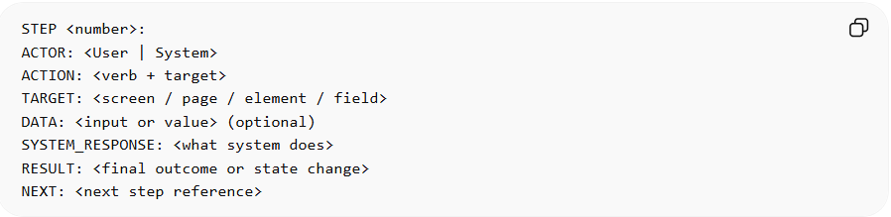
STEP <number>:
ACTOR: <User | System>
ACTION: <verb + target>
TARGET: <screen / page / element / field>
DATA: <input or value> (optional)
SYSTEM_RESPONSE: <what system does>
RESULT: <final outcome or state change>
NEXT: <next step reference>

2. Standard Action Vocabulary
# Source: AI Source: Provided by: [Data Path: Persons Table -> ID Column: 1, Name_En Column: Motasem Essam] -> From: [ChatGPT] on [4/23/2025]
🧭 Navigation Actions
- OPEN
- NAVIGATE_TO
- REDIRECT_TO
- RETURN_TO
- GO_BACK
🖱️ User Interaction Actions
- CLICK
- DOUBLE_CLICK
- RIGHT_CLICK
- TAP
- SELECT
- HOVER
- DRAG
- DROP
🔍 View Actions
- SCROLL_UP
- SCROLL_DOWN
- EXPAND
- COLLAPSE
- ZOOM_IN
- ZOOM_OUT
✍️ Input Actions
- ENTER_TEXT
- FILL_FORM
- SELECT_VALUE
- CHOOSE_OPTION
- UPLOAD_FILE
- ATTACH_FILE
⚙️ System Actions
- LOAD_PAGE
- FETCH_DATA
- VALIDATE_INPUT
- PROCESS_REQUEST
- SAVE_DATA
- UPDATE_RECORD
- GENERATE_OUTPUT
- RENDER_UI

3. System Response Vocabulary
# Source: AI Source: Provided by: [Data Path: Persons Table -> ID Column: 1, Name_En Column: Motasem Essam] -> From: [ChatGPT] on [4/23/2025]
- DISPLAY_SCREEN
- SHOW_MESSAGE
- SHOW_ERROR
- SHOW_SUCCESS
- SHOW_NOTIFICATION
- LOAD_CONTENT
- UPDATE_UI
- REFRESH_VIEW
- REDIRECT_USER
- TRIGGER_EVENT

4. Mobile Interaction Rules
# Source: AI Source: Provided by: [Data Path: Persons Table -> ID Column: 1, Name_En Column: Motasem Essam] -> From: [ChatGPT] on [4/23/2025]
Replace:
- CLICK → TAP
- SCROLL → SWIPE
- HOVER → LONG_PRESS (if needed)
Example:
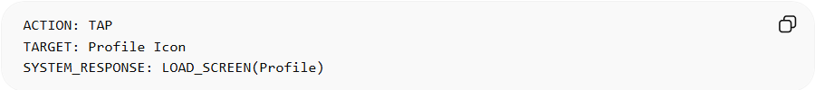ACTION: TAP
TARGET: Profile Icon
SYSTEM_RESPONSE: LOAD_SCREEN(Profile)

Example - Touch Interaction:
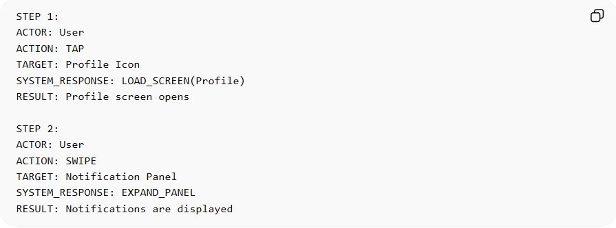
STEP 1:
ACTOR: User
ACTION: TAP
TARGET: Profile Icon
SYSTEM_RESPONSE: LOAD_SCREEN(Profile)
RESULT: Profile screen opens

STEP 2:
ACTOR: User
ACTION: SWIPE
TARGET: Notification Panel
SYSTEM_RESPONSE: EXPAND_PANEL
RESULT: Notifications are displayed

5. Desktop Interaction Rules
# Source: AI Source: Provided by: [Data Path: Persons Table -> ID Column: 1, Name_En Column: Motasem Essam] -> From: [ChatGPT] on [4/23/2025]
Add support for:
- KEY_PRESS
- DRAG_AND_DROP
- WINDOW_FOCUS
- SHORTCUT_KEY
Example:
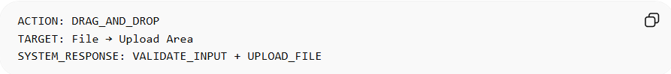
ACTION: DRAG_AND_DROP
TARGET: File → Upload Area
SYSTEM_RESPONSE: VALIDATE_INPUT + UPLOAD_FILE

Example - System + Keyboard:
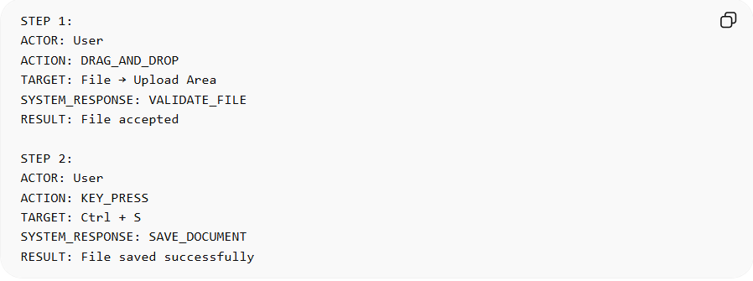
STEP 1:
ACTOR: User
ACTION: DRAG_AND_DROP
TARGET: File → Upload Area
SYSTEM_RESPONSE: VALIDATE_FILE
RESULT: File accepted

STEP 2:
ACTOR: User
ACTION: KEY_PRESS
TARGET: Ctrl + S
SYSTEM_RESPONSE: SAVE_DOCUMENT
RESULT: File saved successfully

6. Data Rule Format
# Source: AI Source: Provided by: [Data Path: Persons Table -> ID Column: 1, Name_En Column: Motasem Essam] -> From: [ChatGPT] on [4/23/2025]
When data is involved:
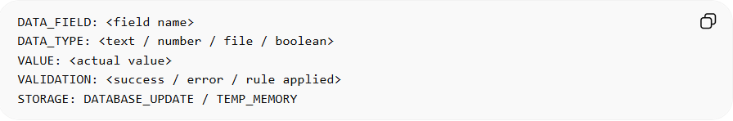
DATA_FIELD: <field name>
DATA_TYPE: <text / number / file / boolean>
VALUE: <actual value>
VALIDATION: <success / error / rule applied>
STORAGE: DATABASE_UPDATE / TEMP_MEMORY

Example: Input + Storage
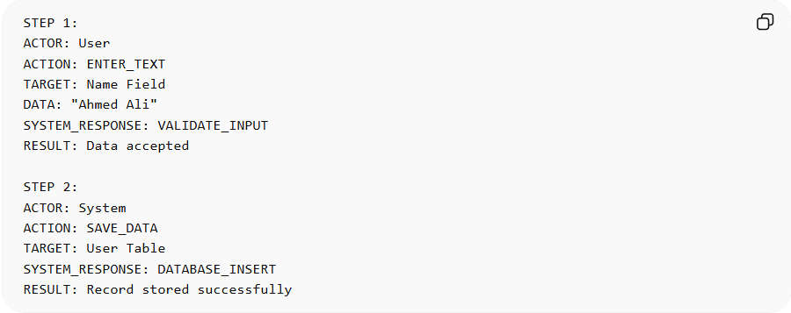
STEP 1:
ACTOR: User
ACTION: ENTER_TEXT
TARGET: Name Field
DATA: "Ahmed Ali"
SYSTEM_RESPONSE: VALIDATE_INPUT
RESULT: Data accepted

STEP 2:
ACTOR: System
ACTION: SAVE_DATA
TARGET: User Table
SYSTEM_RESPONSE: DATABASE_INSERT
RESULT: Record stored successfully

7. State Change Rule
# Source: AI Source: Provided by: [Data Path: Persons Table -> ID Column: 1, Name_En Column: Motasem Essam] -> From: [ChatGPT] on [4/23/2025]
Every interaction must define system state:
- STATE_BEFORE
- STATE_AFTER
Example:
STATE_BEFORE: User not authenticated
STATE_AFTER: User logged in

8. Event Trigger Rule
# Source: AI Source: Provided by: [Data Path: Persons Table -> ID Column: 1, Name_En Column: Motasem Essam] -> From: [ChatGPT] on [4/23/2025]
If something triggers automation:
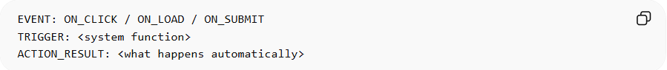
EVENT: ON_CLICK / ON_LOAD / ON_SUBMIT
TRIGGER: <system function>
ACTION_RESULT: <what happens automatically>

Example
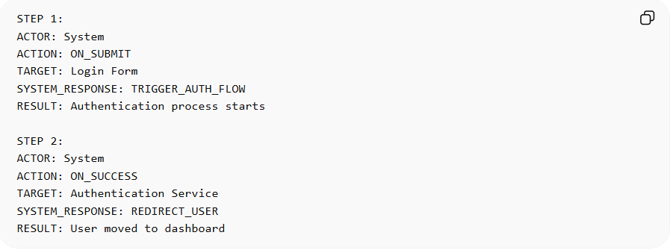
STEP 1:
ACTOR: System
ACTION: ON_SUBMIT
TARGET: Login Form
SYSTEM_RESPONSE: TRIGGER_AUTH_FLOW
RESULT: Authentication process starts

STEP 2:
ACTOR: System
ACTION: ON_SUCCESS
TARGET: Authentication Service
SYSTEM_RESPONSE: REDIRECT_USER
RESULT: User moved to dashboard

9. Golden Rule
# Source: AI Source: Provided by: [Data Path: Persons Table -> ID Column: 1, Name_En Column: Motasem Essam] -> From: [ChatGPT] on [4/23/2025]
Every interaction MUST include:
✔ Actor
✔ Action
✔ Target
✔ System Response
✔ Result
No vague descriptions like:
❌ “System does something”
❌ “User interacts with page”

10. Full Interaction Example (Web App)
# Source: AI Source: Provided by: [Data Path: Persons Table -> ID Column: 1, Name_En Column: Motasem Essam] -> From: [ChatGPT] on [4/23/2025]
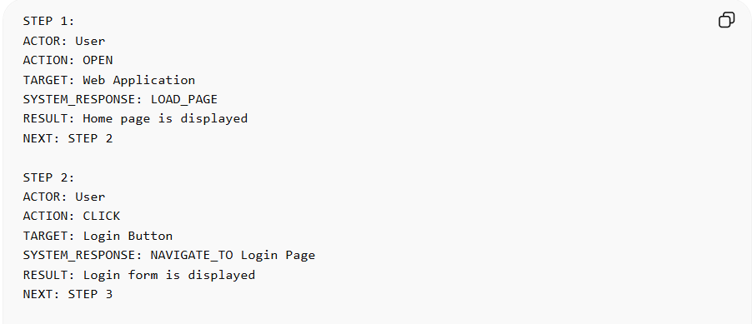
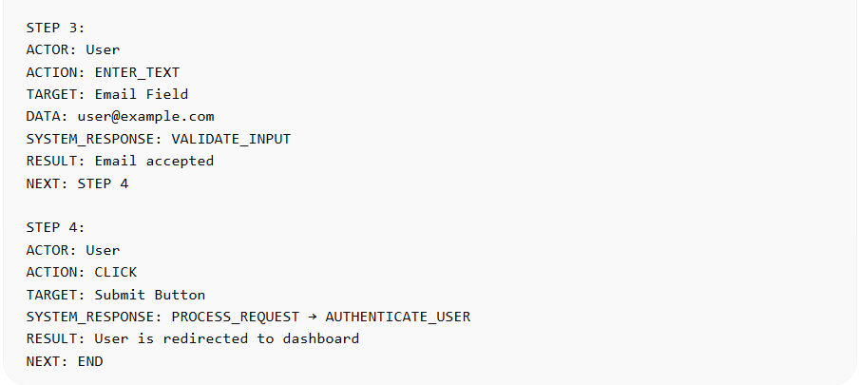
STEP 1:
ACTOR: User
ACTION: OPEN
TARGET: Web Application
SYSTEM_RESPONSE: LOAD_PAGE
RESULT: Home page is displayed
NEXT: STEP 2

STEP 2:
ACTOR: User
ACTION: CLICK
TARGET: Login Button
SYSTEM_RESPONSE: NAVIGATE_TO Login Page
RESULT: Login form is displayed
NEXT: STEP 3

STEP 3:
ACTOR: User
ACTION: ENTER_TEXT
TARGET: Email Field
DATA: user@example.com
SYSTEM_RESPONSE: VALIDATE_INPUT
RESULT: Email accepted
NEXT: STEP 4

STEP 4:
ACTOR: User
ACTION: CLICK
TARGET: Submit Button
SYSTEM_RESPONSE: PROCESS_REQUEST → AUTHENTICATE_USER
RESULT: User is redirected to dashboard
NEXT: END

2-Multi-Action Interaction Rules language (Step-Based Format)

1. Sequential Step Rule (Core Rule)
# Source: AI Source: Provided by: [Data Path: Persons Table -> ID Column: 1, Name_En Column: Motasem Essam] -> From: [ChatGPT] on [4/23/2025]
All actions must be written in ordered steps.
Format:
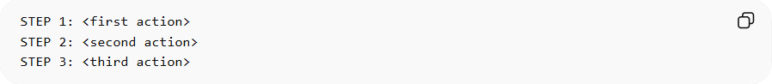
STEP 1: <first action>
STEP 2: <second action>
STEP 3: <third action>
Rule:
- Each step = one clear action only
- Steps must follow logical order
- No skipping system responses

2. Action Separation Rule
# Source: AI Source: Provided by: [Data Path: Persons Table -> ID Column: 1, Name_En Column: Motasem Essam] -> From: [ChatGPT] on [4/23/2025]
Each step must contain ONLY ONE main action.
❌ Wrong:
- STEP 1: User opens app and logs in
✅ Correct:
- STEP 1: User opens app
- STEP 2: User logs in

3. User vs System Separation Rule
# Source: AI Source: Provided by: [Data Path: Persons Table -> ID Column: 1, Name_En Column: Motasem Essam] -> From: [ChatGPT] on [4/23/2025]
Each step must clearly separate:
- USER ACTION
- SYSTEM RESPONSE
Format:
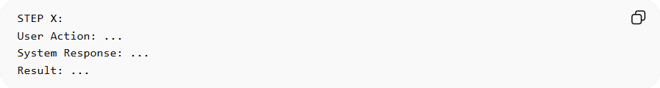
STEP X:
User Action: ...
System Response: ...
Result: ...

4. Flow Dependency Rule
# Source: AI Source: Provided by: [Data Path: Persons Table -> ID Column: 1, Name_En Column: Motasem Essam] -> From: [ChatGPT] on [4/23/2025]
Each step must connect to the next step.
Format:
- NEXT STEP depends on RESULT of previous step
Example:
STEP 1: User opens app → System loads homepage
STEP 2: User clicks login → System opens login page

5. Multi-Action Expansion Rule
# Source: AI Source: Provided by: [Data Path: Persons Table -> ID Column: 1, Name_En Column: Motasem Essam] -> From: [ChatGPT] on [4/23/2025]
If a step contains multiple actions, it must be broken into sub-steps:
Format:
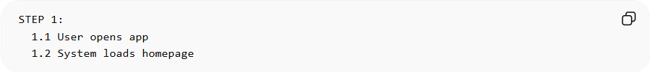
STEP 1:
1.1 User opens app
1.2 System loads homepage

6. Grouped Action Rule (Same Context)
# Source: AI Source: Provided by: [Data Path: Persons Table -> ID Column: 1, Name_En Column: Motasem Essam] -> From: [ChatGPT] on [4/23/2025]
If multiple actions happen in the same screen, group them:
Format:
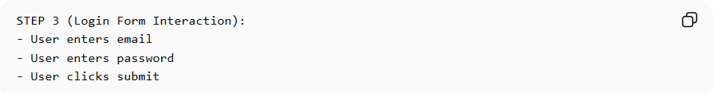
STEP 3 (Login Form Interaction):
- User enters email
- User enters password
- User clicks submit

7. Conditional Action Rule
# Source: AI Source: Provided by: [Data Path: Persons Table -> ID Column: 1, Name_En Column: Motasem Essam] -> From: [ChatGPT] on [4/23/2025]
Use conditions when flow changes:
Format:
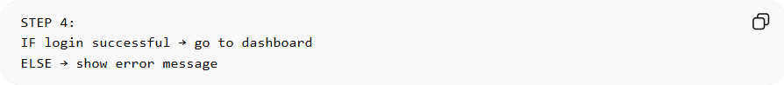
STEP 4:
IF login successful → go to dashboard
ELSE → show error message

8. Loop / Repeat Action Rule
# Source: AI Source: Provided by: [Data Path: Persons Table -> ID Column: 1, Name_En Column: Motasem Essam] -> From: [ChatGPT] on [4/23/2025]
For repeated actions:
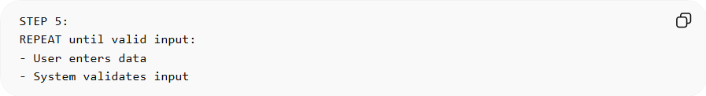
STEP 5:
REPEAT until valid input:
- User enters data
- System validates input

9. State Change Rule
# Source: AI Source: Provided by: [Data Path: Persons Table -> ID Column: 1, Name_En Column: Motasem Essam] -> From: [ChatGPT] on [4/23/2025]
Each step must describe system state change:
- BEFORE STATE
- AFTER STATE
Example:
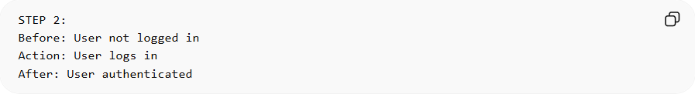
STEP 2:
Before: User not logged in
Action: User logs in
After: User authenticated

10. Final Structured Format (Recommended Standard)
# Source: AI Source: Provided by: [Data Path: Persons Table -> ID Column: 1, Name_En Column: Motasem Essam] -> From: [ChatGPT] on [4/23/2025]
Full Template:
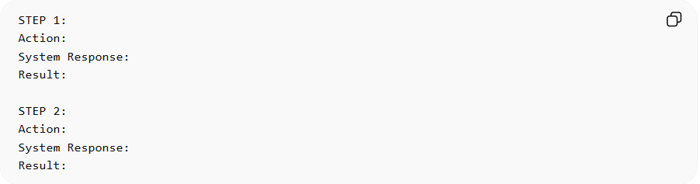
STEP 1:
Action:
System Response:
Result:

STEP 2:
Action:
System Response:
Result:

🧠 Simple Version for Users
# Source: AI Source: Provided by: [Data Path: Persons Table -> ID Column: 1, Name_En Column: Motasem Essam] -> From: [ChatGPT] on [4/23/2025]
If you want a very simple rule users can understand:
“Describe your process using numbered steps. Each step must contain only one action and what happens after it.”

💡 Example Full Flow
# Source: AI Source: Provided by: [Data Path: Persons Table -> ID Column: 1, Name_En Column: Motasem Essam] -> From: [ChatGPT] on [4/23/2025]
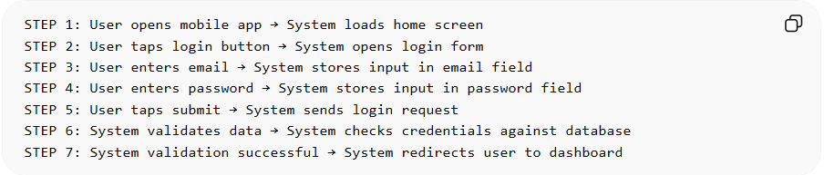
STEP 1: User opens mobile app → System loads home screen
STEP 2: User taps login button → System opens login form
STEP 3: User enters email → System stores input in email field
STEP 4: User enters password → System stores input in password field
STEP 5: User taps submit → System sends login request
STEP 6: System validates data → System checks credentials against database
STEP 7: System validation successful → System redirects user to dashboard

